
Mission Statement
United and nourished by the Word of God and the Eucharist, our culturally diverse Catholic school inspires learning within a nurturing and dynamic environment of academic excellence and Gospel values

The Sentinel Newsletter
March 18, 2026
Principal's Message

As we approach the Easter holiday, I wish to share with you some important information regarding efforts related to safety and security at All Saints.

Over the course of many years, All Saints has developed a strong partnership with the Manassas City Police Department (MCPD), one which has resulted in significant collaboration as well as active shooter response training for our faculty and staff.

As part of this partnership, on Tuesday, April 7 and Wednesday, April 8, members of the police department and representatives from other law enforcement agencies will conduct onsite active shooter trainings in our school building. The training exercises, similar to those that occurred in prior years, will further increase the police department’s familiarity with our campus and the layout of our facility while providing them the benefit of training in an actual building.

These trainings will take place during the week of Easter when the school will be closed. In advance, of the training, MCPD will provide exterior signage so that any visitors to the school will be aware that a training exercise is occurring.

We are grateful to all of the members of the police department for their continued partnership with All Saints and for all that they do to ensure the safety and well-being of our local community.

Secondly, I wish to share that our next drill with students will take place in the Church on Friday. After consultation with law enforcement, we have revised our procedures and wish to provide our faculty, staff, and students the opportunity to practice our updated response plan in the Church.

As with many of our drills, I will be sharing with the students that the exercise will provide us yet another opportunity to practice one of the ways that we keep ourselves safe while at All Saints. Additionally, we will be referring to this as an emergency drill, rather than a lock-down drill.

Know of our continued commitment to the safety and well-being of the students entrusted to our care. Should you have any questions, please do not hesitate to let me know.

Wishing you continued blessings during this Lenten season!
Shining our light, building a community of saints.

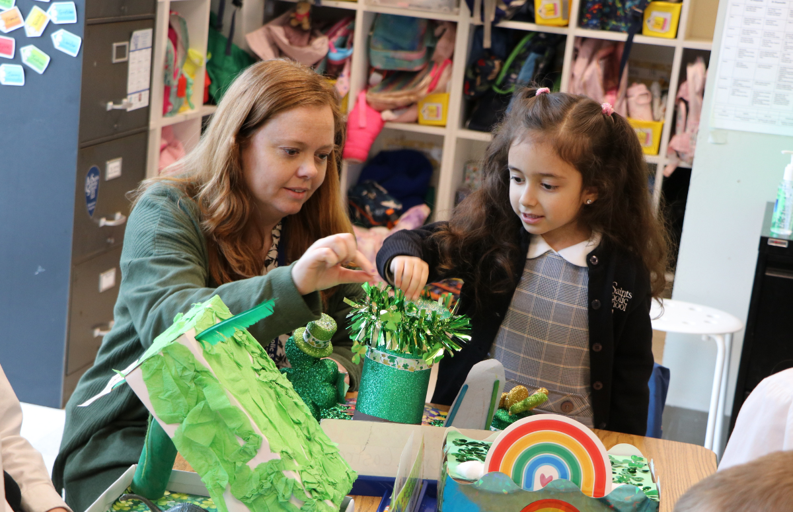   | 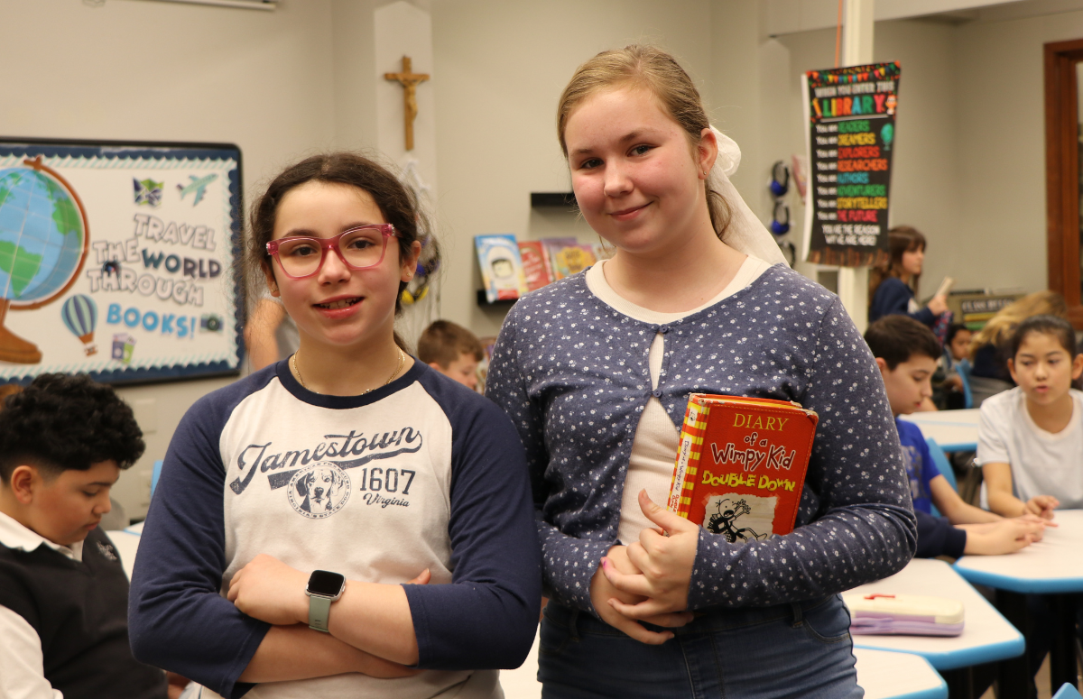  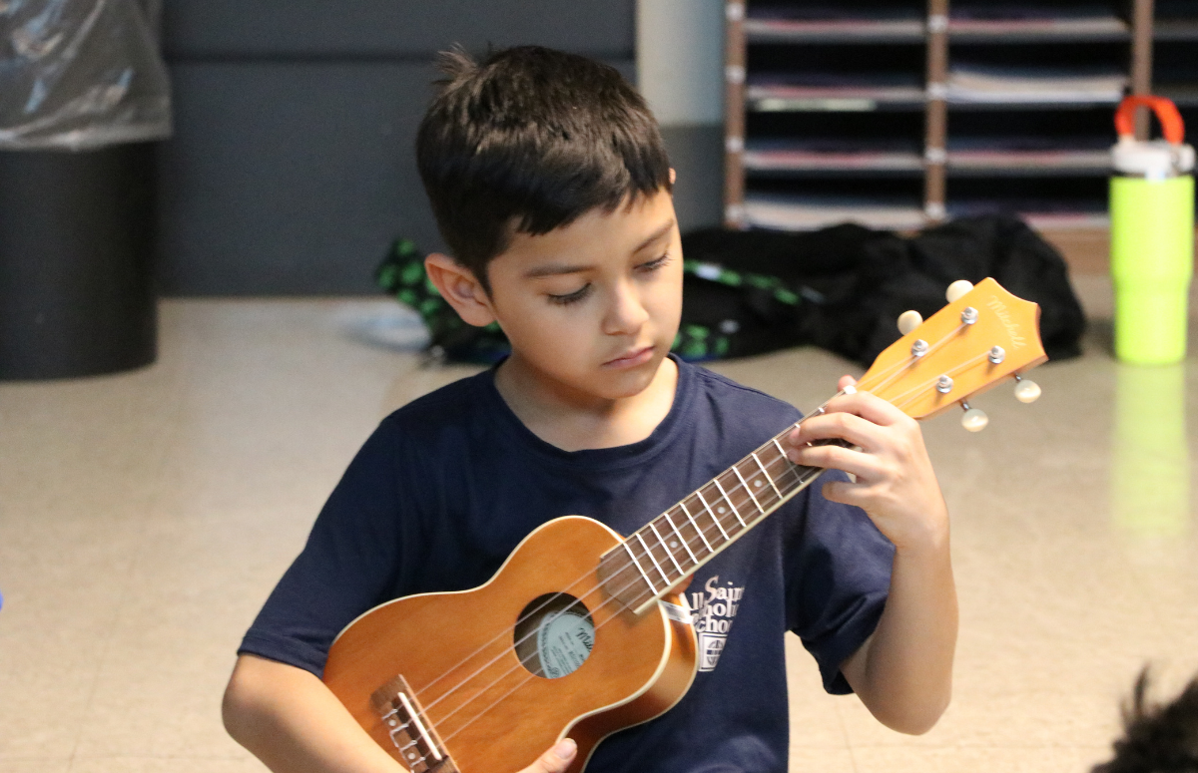

Girls Volleyball Clinic at John Paul - March 28th
Join us at Saint John Paul the Great Catholic High School for our Girls Volleyball Clinic on Saturday, March 28th from 9-11am! Open to 4th - 8th grade girls! Participants will have the opportunity to work on fundamentals while receiving guidance from JP coaches and JP student athletes! We hope to see you there! Click here to start your registration: https://saintjohnpaul.mypaysimple.com/s/middle-school-event-registration

Lenten Retreat for Students - March 23
As part of our DFE Five Year Plan, again this year we will host a retreat for all of our students that will occur during a regular school day. It will be a day on which we will set aside the regular class schedule in order to provide our students with an immersive experience of the Catholic faith. In doing so, our goal is to further unite our school as a faith community and to offer our students an additional opportunity to grow in their relationship with Christ.

A faculty committee, led by Ms. Mallon, has planned a day of prayer and grade-level activities that will occur on Monday, March 23. Look for more details, including a schedule for the day, next week as we continue to plan for this new tradition at All Saints.
Lenten Rice Lunch – Friday, March 27
As we approach the conclusion of Lent, we want to thank you for encouraging your children to participate in the CRS RiceBowl project. This initiative has provided our students a very specific way to embrace the practice of prayer, fasting, and almsgiving during this liturgical season.
In support of the effort, on Friday, March 27th, the cafeteria will host a simple lunch, the proceeds of which will benefit the RiceBowl project. As a sign of our solidarity with the poor around the world and in an effort to help students gain a better understanding of poverty, the lunch will consist of one bowl of rice and water. This will be the only food and drink available for purchase on that day. Although participation is completely voluntary, we are hopeful that many of the children will embrace this opportunity and recognize it as a chance to increase their empathy for those suffering in our world.
The cost of the lunch is $5.00 and should be paid through the online lunch accounts. Please check your child's account to ensure you have sufficient money in the account if you are able to participate. Students may bring a lunch from home if they prefer and are reminded to bring a drink if they so choose as only water will be available in the cafeteria.


Bread of Life Food Drive
During this Lenten season, we are pleased to host the All Saints’ Bread of Life Food Drive to benefit the Bethany Food Pantry and St. Lucy Project from March 17 – 27, 2026.

In 1992, the University of Notre Dame Club of Staten Island launched this community service initiative, and it has since spread to communities around the country. All Saints is the first school in Virginia to participate. All Saints’ Bread of Life Food Drive will assist individuals and families in our local community in need of food assistance. Please see details below regarding our 2026 food drive:

When will the food drive take place?
All Saints Bread of Life Food Drive will run from Tuesday, March 17 – Friday, March 27, 2026. All Saints students from the National Junior Honor Society (NJHS) will help organize and promote the drive. Some students from our seventh grade video production class are assisting with the creation of video promos to encourage participation throughout the week.

Where does the food go?
Almost a quarter of a million people in the Arlington Diocese are “food insecure,” meaning they do not know where their next meal will come from. Our school’s Bread of Life Food Drive will benefit the St. Lucy Project and All Saints’ Bethany Food Pantry to assist families and individuals living within Manassas, Manassas Park, and Prince William County.

What can you do to help?
During the drive from March 17-27, your child can bring in food donations in the morning and leave them in the boxes that will be outside each classroom. Donations can also be brought to the All Saints school office (Monday - Thursday) between the hours of 8:00 AM–3:30 PM.
What food should I donate to All Saints Bread of Life Food Drive?
During the first week of the drive, we will be collecting non-perishable food per the chart below. During the second week, we are adding fresh fruits and vegetables to our collection. Please see the grade level list below:
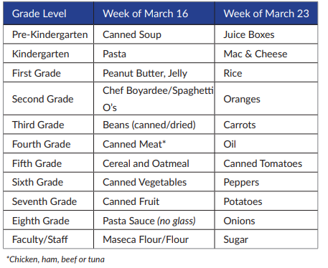

Bread of Life Food Drive – 2026 Brochure

If you have any questions regarding the Bread of Life Food Drive, please contact Mrs. Cecilia Mondarez at cmondarez@allsaintsva.org.

Thank you in advance for your generosity and support of this Lenten community service project to benefit those in need of food assistance.
All Saints wishes to extend sincere thanks to the University of Notre Dame Club of Staten Island for their organizational and logistical support.

- Catholic Relief Services (CRS) Rice Bowls
Students have received a cardboard rice bowl into which they can place their donations during Lent. All of the funds will benefit CRS Rice Bowl which is sponsored by Catholic Relief Services, the official international humanitarian agency of the Catholic community in the United States.
At the end of Lent, families will be asked to convert the contributions from their children into a check to be submitted to All Saints after which our school will forward all of the funds to the diocese.
Here are some strategies that you may wish to consider in shaping your family’s Lenten plan:
  - Use your CRS Rice Bowl and Lenten Calendar each day to guide your Lenten prayer, fasting, and almsgiving.
  - As a family, read the online Stories of Hope and daily reflections to inspire your Lenten journey and guide your Lenten almsgiving.
  - Prepare simple meatless meals on Fridays throughout Lent, in solidarity with our brothers and sisters around the world. Recipes for simple meals can be found on the CRS website.
For more information, including spiritual reflections, short video presentations on the topic of Lent, and virtual Stations of the Cross, please see the link below.
https://www.crsricebowl.org/

- Lunch Menu - March
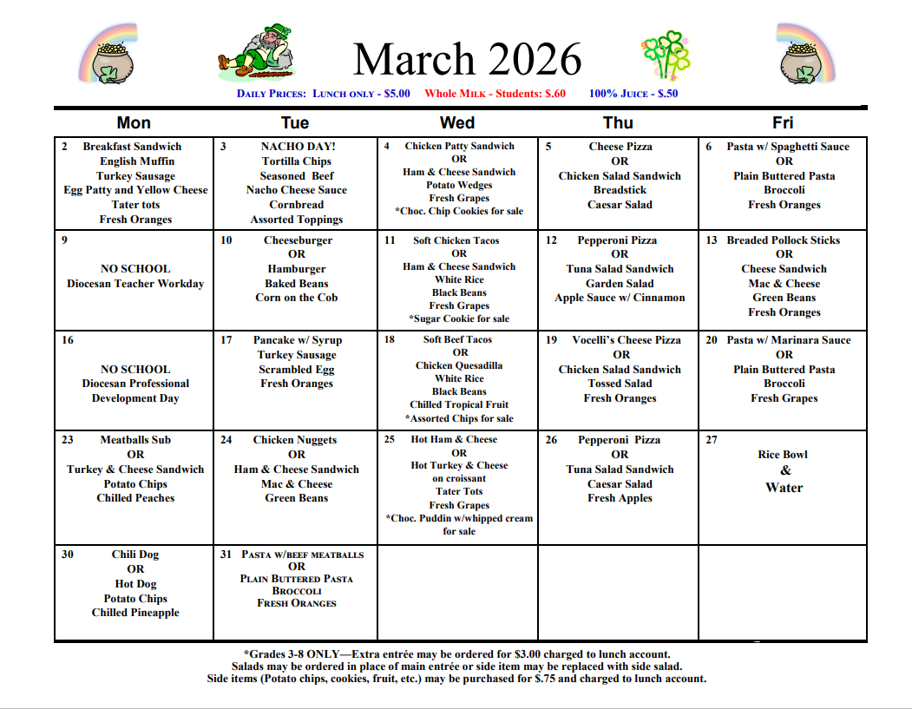

Open House – March 26 (6:00 p.m.)
All Saints Catholic School will host an Open House for prospective parents on Thursday, March 26 beginning at 6:00 p.m. in the Parish Activities Center. All parishioners and members of the community interested in learning more about our school are cordially invited to attend. For more information, please contact Mrs. Mary Rodriguez, Administrative Assistant, at (571) 516-3170 or mrodriguez@allsaintsva.org.

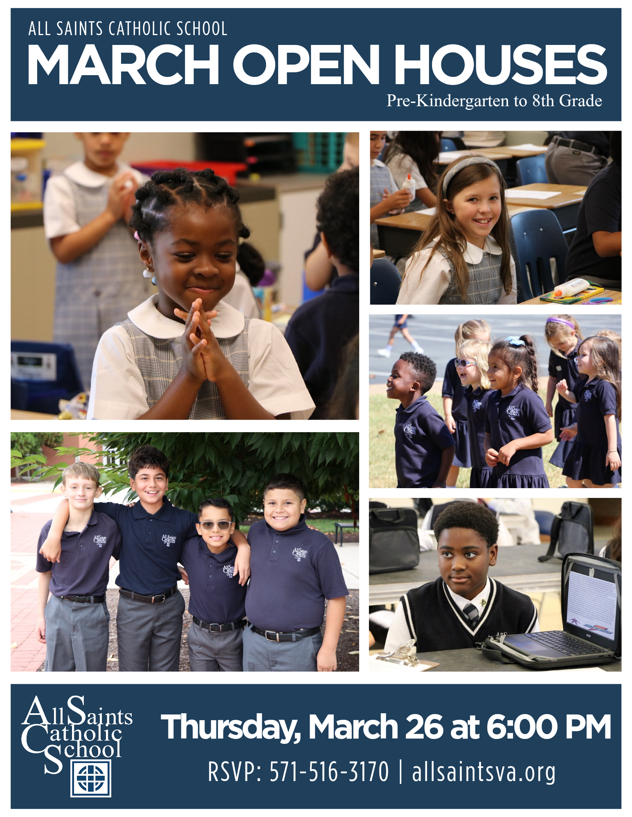

- Girls Volleyball Clinic at John Paul - March 28th
Join us at Saint John Paul the Great Catholic High School for our Girls Volleyball Clinic on Saturday, March 28th from 9-11am! Open to 4th - 8th grade girls! Participants will have the opportunity to work on fundamentals while receiving guidance from JP coaches and JP student athletes! We hope to see you there! Click here to start your registration: https://saintjohnpaul.mypaysimple.com/s/middle-school-event-registration
- Diocesan Teacher Job Fair - March 21
Each spring the Diocese of Arlington hosts a Teacher Job Fair for those interested in learning more about the ministry of Catholic education. This year the event will take place at St. Bernadette School from 9:00-11:00 a.m. on Saturday, March 21. For more information about the event, please see the link below.
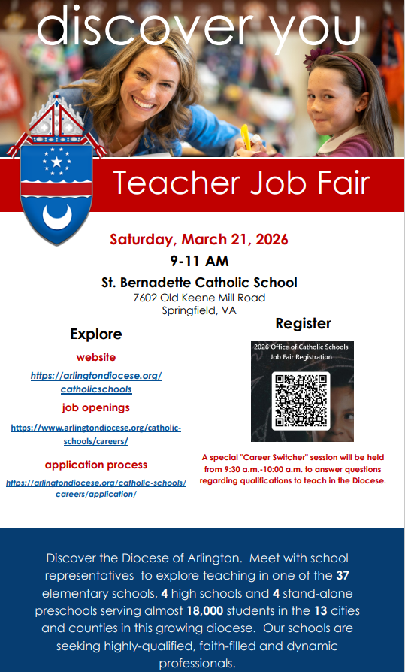
- ART, DRAMA, MUSICAL THEATRE CAMPS for K-12 in a Catholic setting
Spotlight on the Arts Summer Camps offers Broadway Spotlight, Drama Bootcamp, Art Explorer, and Arts & Crafts Fun Camp this July to students across the Diocese.
This July 13th - 24th young people are invited to experience top level instruction as they engage in creative fun through Acting, Visual Art, Music, and more!
Taught by professional Catholic educators very accomplished in their area of expertise, each week concludes with either an Art Showcase or a Theatrical Performance by the campers.
Through March 31st, all camps are $35 off plus everyone gets a free t-shirt. Additionally, there are extra discounts for families that enroll 3 or more kids! Learn more and register at www.SpotlightSummerCamps.com

- The PVI Players are proud to present The Sound of Music, one of the most beloved musicals of all time.
Set in Austria in 1938, the story follows Maria, a spirited young governess who brings music and renewed joy to the von Trapp family. As the Nazi regime rises to power, the family must face danger and make courageous choices that will change their lives forever. Featuring cherished songs and a powerful story of faith, family, and resilience, this production promises to be a highlight of the spring season.
Purchase tickets today! [https://cur8.com/40072/project/137212]
Performance Dates:
·Saturday, March 21 at 7 p.m.
·Sunday, March 22 at 2 p.m.
·Friday, March 27 at 7 p.m.
·Saturday, March 28 at 7 p.m.

- Yearbook Orders
A wonderful way to commemorate the school year is by purchasing an All Saints Yearbook. Our 2025-2026 school yearbook is available to order now!
The cost is $25.00 per yearbook, and personalization is available for an additional fee of $5.00.
All orders must be placed online through the link below:
  - Please visit the Lifetouch website to order online: http://www.buytheyearbook.com/.
  - The All Saints school code is 733573.
For questions regarding the All Saints Catholic School Yearbook, please contact Mrs. Cecilia Mondarez at cmondarez@allsaintsva.org.
Thank you for your continued support of the yearbook and All Saints Catholic School.

Upcoming Events

Thursday, March 19
School Mass – Solemnity of St. Joseph (8:30 a.m.)
National Junior Honor Society Induction Ceremony (1:30 p.m.)

Saturday, March 21
Diocesan Job Fair (St. Bernadette School/9:00 – 11:00 a.m.)

Wednesday, March 25
PTO Executive Committee Meeting (PAC Atrium/7:00 p.m.)

Thursday, March 26
Stations of the Cross – Grades K-8 (2:15 p.m.) – Closed Event
Faculty Meeting (3:30 p.m.)
Open House (PAC/6:00 p.m.)

Friday, March 27
School Mass (8:30 a.m.)
Bread of Life Food Drive Ends
Wednesday, April 1
School Mass (8:30 a.m.)

Thursday, April 2
7th Grade Passion Play (PAC/10:45 a.m.)
Noon Dismissal (Holy Thursday)

Friday, April 3
Holiday (Good Friday)

Monday, April 6
Easter Holiday Begins

Monday, April 13
School Resumes
Change to Summer Uniforms

Thursday, April 16
Enrollment Management Team Meeting (PLC/7:00 p.m.)

Friday, April 17
School Mass (8:30 a.m.)

Saturday, April 18
PTO Bingo Night (6:00 p.m.)

Monday, April 20
SCA Sponsored Spirit Week

Wednesday, April 22
Religion Assessment – Grades 5 & 8

Thursday, April 23
School Mass – St. George, Martyr (8:30 a.m.)

Friday, April 24
Holiday (Parish Festival Prep Day)

