The Sentinel
November 1, 2017
Principal’s Message
Today is the patronal feast of our school and parish – All Saints Day! It is a day marked by celebration beginning with Mass and the procession of 3rd grade saints, followed by the 8th grade presentation in the Parish Activity Center. It is a day on which the very best efforts and learning of our students are fully integrated with our faith and showcased for parents and visitors to enjoy. Whether it is the work of our second grade students sharing key facts about a saint they have studied or the beautiful display of pencil sketches with reports outside of the fifth grade classrooms, our school resounds with great pride in our namesake and the wonderful examples of the holy men and women who have gone before us.
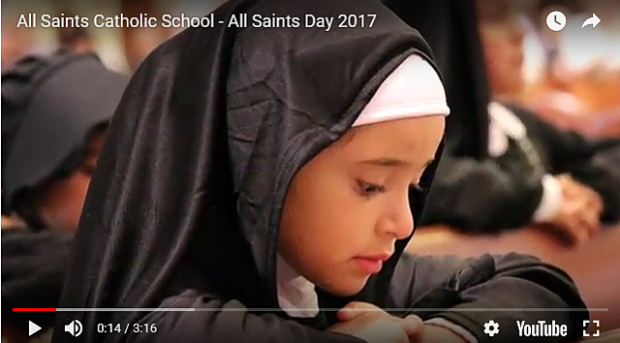
On this occasion, we thank you again for providing for your children the gift of a Catholic education and for choosing All Saints. Happy Feast Day!
******************************************************************************
On Monday, November 20th we will host our annual Thanksgiving Luncheon. All parents are cordially invited to attend this special event with their child(ren). For the third year in a row, we are linking this celebration to an outreach effort to benefit the St. Lucy Project, a large warehouse in Manassas where staff and volunteers process and distribute donations to numerous food pantries in our region. This initiative is in support of Catholic Schools Care about Catholic Charities Week which is scheduled for the week of December 3rd. Again this year, donations may be included with your Thanksgiving Luncheon payment. Please see the order form from the cafeteria for more details (a copy of the order form is linked below). Additionally, the Peace & Justice Players will set up a collection station at the entrance to the cafeteria. We invite your participation again as we work together to support the mission of Catholic Charities and to make a positive difference in our community of Manassas.
Report Cards & Parent-Teacher Conferences
On Friday teachers will distribute first quarter report cards to students in grades 1-8 and progress reports for those in Kindergarten. In preparation for the parent-teacher conferences next week, please take some time to review all of the information provided by the teacher, noting any special areas of success or difficulty. We encourage you to speak with your child to determine if there is anything that he or she would like you to address with the teacher. Additionally, we invite you to make a list of any questions or concerns that you wish to discuss during the conference. We look forward to these meetings and the opportunity to continue to partner with you in support of your child’s success.
Virtues in Practice – November
Virtue of the Month: Humility
Definition: Accepting your limitations and God-given talents.
Saints: St. John the Baptist (PK-2); St. Pio of Pietrelcina (3-5); St. Theresa of Lisieux (6-8)
Important Reminders
Veterans Day Celebration – November 9th
Join us as our school community honors the commitment of the men and women who have served our country in the United States Armed Forces. We cordially invite all active duty, reserve, former and retired military personnel to attend our school Mass on Thursday, November 9th at 8:30 a.m. Following the Mass, there will be a ceremony in the Parish Activity Center and a reception for our honored guests in Father Kelley Hall.
Prospective Teacher Information Meeting – November 14th
Are you interested in teaching for the Catholic Schools in the Diocese of Arlington? There are 44 schools within the Diocese offering instructional programs for all ages from pre-school through high school. Perhaps your certification has expired, or perhaps you are thinking of changing careers or returning to teaching after a period of absence. Do you have questions about qualifications to teach? Would you like to learn more about the mission of teaching in a Catholic School in a nurturing and caring, Christ-centered environment? Plan to attend the Information Program for Prospective Teachers on Tuesday, November 14th from 1:00-3:00 p.m. in Father Kelley Hall.
Open House for 2017-2018 School Year – November 16th
All Saints Catholic School will host an Open House for prospective parents on Thursday, November 16th beginning at 9:00 a.m. in Father Kelley Hall. All parishioners and members of the community interested in learning more about our school are cordially invited to attend. Following a presentation and introduction at 9:00 a.m., tours of the facility will be provided. For more information, please contact Mrs. Joyce D’Eugenio, administrative assistant, at (703) 393-1490.
Band Concert Rescheduled – May 15th
Confirmation for our 8th grade students will take place on Tuesday, May 22nd at 7:00 p.m. The band concert, originally scheduled for the same evening, will now occur one week prior on May 15th beginning at 7:00 p.m. in the Parish Activities Center.
THANKSGIVING LUNCHEON -VOLUNTEERS NEEDED
Help is needed with set-up, clean-up, food preparation and food service for the Thanksgiving Luncheon on Monday 11/20. Volunteer shifts are designed so you will be able to sit and enjoy your meal with your children. Please consider helping for at least one shift throughout the day. Sign-up on Help Counter: https://www.helpcounterweb.com/ci/signup/140ea5813bc (VIRTUS required) Any questions, please contact Carol Rice ckrice@verizon.net

Upcoming Events
Thursday, November 2nd
- City of Manassas Speech Screenings
Friday, November 3rd
- 1st Quarter Report Cards sent Home
- PowerSchool Parent Portal Reopens
Monday, November 6th
- Diocesan Vocations Awareness Week
Wednesday, November 8th
- Gold Medal Readers Celebration (1:30 p.m.)
Thursday, November 9th
- School Mass & Veterans’ Day Ceremony (8:30 a.m.)
- Noon Dismissal
- Parent-Teacher Conferences
- Spirit Event: Ledo Pizza – Liberia Avenue (11:00 a.m. – 10:00 p.m.)
Friday, November 10th
- Parent-Teacher Conferences
Newsletter Links
- THANKGIVING LUNCHEON 2017 Memo & Order Form
- Bishop Ireton Open House Flyer
- Bishop Ireton-Theatre Arts Production of 12 Angry Jurors
- Pilgrim Virgin Statue Sign-Up

